|  |  |
| --- | --- |
| **Assetline Leasing Company Limited** | |
| 120, 120A, Pannipitiya Road, Battaramulla, Sri Lanka . |  |



**Real Estate Business Proposal**

**Prepared For:** AssetLine Leasing Company Ltd.

**Prepared By:** Modular4 Solutions (Pvt) Ltd.

# Executive Summary

# **Real Estate Sector in Sri Lanka**

Laden by the hope of a virtuous future, SriLanka teems with infinite possibilities and is preparing itself to become a destination of choice.

Since the end of the civil war in mid-2009, the country’s economy has been on a strong growth trajectory led by determined rebuilding measures, surging tourism and increased investor confidence. After a sharp decline in growth during 2008-2009, it expanded rapidly by 8% in 2010 and 2011, and a further 7-8% is expected in 2012. This makes it the second fastest growing economy in emerging Asia, after China. Low interest rates and moderate levels of inflation will boost trade and industry in the medium term, and the government is also placing increased emphasis on carrying out large infrastructure projects, which will not only improve communications in established areas, but also unlock the hidden potential of other locations.

With several local and domestic investors looking to capitalise on a promising economic growth environment and improving infrastructure, real estate has witnessed an upward trend in demand and pricing. The recent upswing in the service sector from finance, tourism, and the IT/ITES industry in Colombo, has triggered a healthy demand for residential space in the Greater Colombo real estate market. The development of premium condominium projects is most prominent in the Central Business District; and sub-divided developments, row houses and villas in the peripheral suburbs have emerged as the preferred choice for middle-income buyers. However, with rising land and construction costs, it is important to be aware of the affordability of upcoming supply. Also, whether it is happening in the right locations and will it be adequate to meet the growing demand?

Retailing in the country has largely been confined to established high streets, with domestic retailers catering to an urban population. Lately, Colombo has witnessed the development of some organised retail establishments in up-market locations. Given the current trend in organized

retail and brand presence, will there be significant scope for enhancing targeted retail capacity in upcoming residential locations, and will there be an opportunity to expand retail services for food and beverages, healthcare, personal care and tourism?

The demand for commercial office space is driven by growth in the banking, IT/ITES and tourism sectors. While Banking, Financial Services and Insurance have an established presence with captive properties across Colombo, IT/ITES is emerging as an attractive sector. According to SLASSCOM, over 40,000 people are employed in the IT and BPO industry in Colombo and the workforce is growing at over 20% annually with low attrition rates of 10-15%. Colombo is comparatively cost competitive and has lower upward wage pressure than many established global sourcing destinations. With limited operational Grade A office space in the city, the demand is trickling down to inferior grade properties. Will this dearth of quality office space continue or will developers and investors perceive this as an opportunity to build more and attract global occupiers? What cost advantage does office real estate in Colombo provide for outsourcing?

The Sri Lanka Tourism Development Authority figures show that tourism forms 0.6% of the country’s total GDP, and is one of the fastest growing sectors in the economy, growing by 39.8% in 2010. With the Government setting the target for 2.5 million tourist arrivals by 2016, hotels and resorts are set to mushroom in tourist destinations. Are there enough hotels to meet the burgeoning demand from tourism? Will Sri Lanka remain a budget destination or transform itself into an exotic destination for affluent global vacationers?

**Middle Income Real Estate Market**

Due to a variety of economic and social factors, the main focus for the middle income segment is in the arena of newly built houses and plots of land. This segment of the market tends to diverge into the suburbs of Colombo city, opting for larger properties 20-30 km away from the city. The fastest growing segment in terms of deal closure in the real estate market is associated with the middle income earners in Sri Lanka.

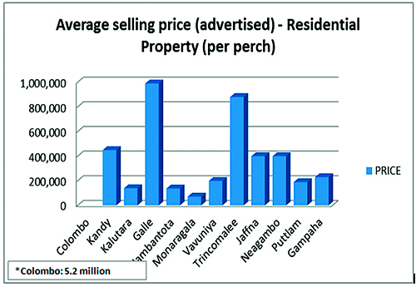

The middle income segment is heavily dependent on interest rates and the domestic economy. Unemployment rates, inflation rates and interest rates have direct consequences on this market segment. Their ability to be provided with loan facilities from banks has expanded in recent years and therefore has resulted in an expansion of affordable housing options, in Colombo as well as in the suburbs. This is consistent with increases in public housing initiatives, falling unemployment rates and increases in foreign remittances.

Cultural and societal trends that are also leading to increased demand for home loans and wider home ownership in Sri Lanka, especially amongst young newly married couples who are increasingly looking to own their own home as compared with the option of living with their parents.

The middle income segment consists mainly of first time buyers, young couples, 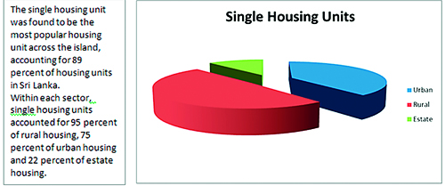and families. Studies indicate that the market has grown at a compound rate with the escalation of per capita income and changing patterns of consumption and saving habits in the recent past.

Government data indicate that the urban population is about 30 per cent. Nationwide, close to 90 percent of the housing units are owner occupied. Sri Lanka’s small rental market – only 5.4 per cent of the total housing stock – is dominated by high-end luxury apartments. The market for middle- and low-income renters is almost non-existent. There’s now a severe housing shortage, which could reach 650,000 units by the end of the year, in a country of around five million households, according to the Ministry of Housing and Plantation Infrastructure.

The demand for house rehabilitation and upkeep is met in a limited manner currently. The country has embarked on a gradual 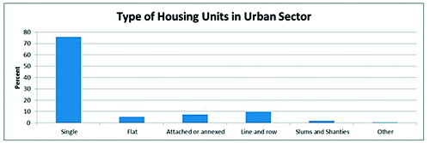transition from a system of directed credit in a highly segmented market toward an integrated, market-driven housing finance system. Nurturing home mortgage markets requires a stable macro-economy, low inflation, and careful fiscal policies. The share of state-owned housing institutions—such as the State Mortgage and Investment Bank (SMIB), the Housing Development Finance Corporation (HDFC), and the National Savings Bank (NSB)—has come down to about one third of the mortgage market share, as the private sector has displaced the government as the primary housing finance provider.

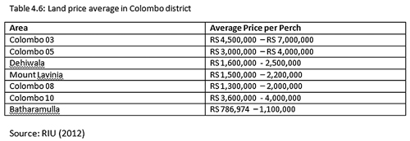

Trends in the land market

In the post-war scenario, interest in land purchases has increased significantly according to sources operating in the industry. Areas like Kandy, Galle and Hambantota are showing evidence of growth, especially with the nearing of completion of the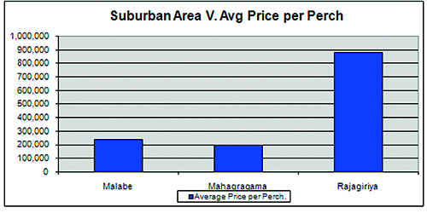Southern highway for the latter two cities. The land market in the Western Province areas like Colombo, Kalutara and Gampaha have been comparatively slow yet steady, with only a marginal peace-dividend impact.

All foreign acquisition of land is taxed at 100 per cent in Sri Lanka. All land purchases must be registered with the Registrar of Lands along with the ‘Deed of Transfer’. Stamp Duty tax will be applicable on this, depending on the value of the land. There are no taxes on capital gains with regard to property values. The table above provides some indicative land prices for Colombo city and suburban areas based on current advertised rates.

|  |  |
| --- | --- |
| http://www.sundaytimes.lk/140420/uploads/Graph-61.jpg | http://www.sundaytimes.lk/140420/uploads/Graph-7.jpg |
| http://www.sundaytimes.lk/140420/uploads/Graph-8.jpg |  |

# **Real Estate Management System – Why?**

The proposed real estate management system in discussion would bring about returns across many dynamics to the customer.

One of the key aspects of the system is that it assists the organization in keeping track of all the inventory or assets owned by the company and which are being provided for sale to the market, with the clear identification of its details, thereby ensuring that the system more or less acts as an asset management software as well. The system allows the organization to keep track of multiple projects at any given time, thereby assisting the users in the prioritization of projects and related activities as well.

Further to this, the facility of updating reservation details through the system ensures that the organization and responsible personnel is allowed to keep track of the assets, thereby assisting in prompt decision making and minimized human errors. Minimal usage of documentation and maintenance of information through paper based mechanisms could assist in being eco-friendly and as an organization, could contribute towards sustainable practices as well.

Moreover, systemized workflows and processes allows better control within the organization due to authorized users being provided with authors tasks, ensures that organization wide procedures and standards are followed at all times. Any biasness and the provision for any unethical practices could also be minimized and controlled.

Cost controlling being one of the key aims of any organization, this system would assist in the tracking of income earned and expenditure spent through the sales would allow better visibility towards the numbers in detail. Further merits in the identification of provisions for budgeting for the future too could be conducted, thereby assisting the organization in being proactive rather than reactive.

Along with this, the system would also assist in management decision making through the provision of dashboard and reporting tools in extracting and analyzing reports across various variables. Extraction of price lists, evaluation of current projects, being able to keep track of the aging assets through age analysis reports etc, would be value additions provided through the system which would assist in making informed decisions and thereby enhancing the quality of work, resulting in the quality of services provided as well.

On the other hand, through the Admin module provided, the organization would be able to assign a responsible and authorized personnel is assigning and creating various activities and tasks along with assigning of roles and workflows to users as well. This would be provided with maximum security, thereby ensuring that any organization wide sensitive information would be kept confidential and secured at all times.

Being able to automate the countless transactions required in the real estate management process of accurate tracking, scheduling, reserving and executing of assets through pre-defined and customizable workflow processes empowers the real estate asset management, with standardized processes. Therefore this system would benefit the company across many areas and would eventually be a key driver of growth for the future of the organization as well.